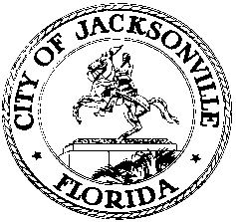
Tommy Hazouri  City Council President  At-Large, Group 3  E-Mail: thazouri@coj.net |  | 117 West Duval Street  City Hall, Suite 425  Jacksonville, Florida 32202  Office (904) 255-5217
 | OFFICE OF THE CITY COUNCIL

March 11, 2021
10:00 A.M.
MEETING NOTICE

Notice is hereby given that UF Shands will hold a Community Forum and Update regarding COVID-19 and related matters for the Jacksonville City Council and other community leaders. This meeting will be held, today, Thursday, March 11, 2021, 10:00 A.M. by teleconference. To participate, members of the public can call: 1-855-949-3274 Pin-7153982

All interested parties are encouraged to attend.
For additional information or correspondence, please contact Amber Lehman, Secretary to the President, At-Large, Group 3, (904) 255-5185.

cc: Council Members and Staff
Cheryl L. Brown, Director/Council Secretary
Jessica Matthews, Chief, Legislative Services Division
Sharonda Davis, Supervisor, Legislative Services Division
Jeff Clements, Chief, Research Division
Kristi Sikes, Chief, Administrative Services Division
CITYC@COJ.NET
Electronic Notice Kiosk – 1st Floor City Hall
Public Notice System – City Council Web Page
Media Box
File Copy

